
NSO Installation
Acceptance Test Procedure Document
Production Environment: CFS VIP 172.28.2.26 | RFS VIP 172.28.2.27 (HA Primary/Secondary)
LSA Deployment (CFS/RFS)
Cisco Network Services Orchestrator (NSO v6.4.11)

Revision History
Revision No. | Date of Submission | Description of Revision |  | Prepared  By | Date of submission for Review |  | Review completed Date
1.0 |  | Initial Version |  | L&T
Prepared by |  |  | Reviewed By |  |  | Approved by

Contents

Revision History 2
Contents 3
1. Introduction 4
Preface 4
Audience 4
Scope 4
Related Documents 4
Deployment Details 4
2. Acceptance Test Plan 4
Overview 4
3. Test Result Summary 5
Test Checklist 5
4. Access and System Health Verification 5
Test Case 1: Authenticating into the NSO Environment (Login) 5
Test Case 2: Verifying System Health and Runtime Status 10
5. Device Connectivity and Configuration Synchronization 17
Test Case 3: Validating Device Reachability and Sync from the CFS 17
Test Case 4: Validating Device Reachability and Sync from the RFS 22
6. Package Management 29
Test Case 5: Verifying Installed Package Status (Service Package Check) 29
Test Case 6: Package Upgrade Workflow 39

1. Introduction

Preface
The objective of this document is to provide the Acceptance Test Plan (ATP) for the Cisco NSO (Network Services Orchestrator) LSA deployment, covering the CFS and RFS clusters for the T-Fiber network.
This acceptance test plan documents the tests performed on the Cisco NSO (Network Services Orchestrator) platform to validate the installation, connectivity, and operational readiness of the LSA (Layered Service Architecture) deployment across the CFS (Customer Facing Service) and RFS (Resource Facing Service) layers for the T-Fiber network.

Audience
The document is intended for:
- T-Fiber Project Engineering Team
- TNOC Team

Scope
The scope of this ATP document is limited to the verification of the installation, connectivity, and operational readiness of the Cisco NSO LSA deployment across the CFS and RFS clusters (VIPs 172.28.2.26 and 172.28.2.27) for the T-Fiber network in Production.

Related Documents
- Low Level Design (LLD)

Deployment Details
Environment | RFS Node | Cluster Nodes | Deployment Type
CFS HA Cluster - Virtual IP (VIP) 172.28.2.26 | Nodes: 172.28.2.11 (Primary), 172.28.2.12 (Secondary), 172.28.2.13 (Secondary) | RFS HA Cluster - Virtual IP (VIP) 172.28.2.27 | Nodes: 172.28.2.14 (Primary), 172.28.2.15 (Secondary), 172.28.2.16 (Secondary) | CFS: cfs-node-11, cfs-node-12, cfs-node-13 (behind VIP 172.28.2.26) | RFS: rfs-node-1, rfs-node-2, rfs-node-3 (behind VIP 172.28.2.27) | LSA (Layered Service Architecture) - RFS/CFS, with High Availability (HA) via Virtual IP (rule-based algorithm)

2. Acceptance Test Plan

Overview
The purpose of the ATP tests in this document is to assess the overall functionality, connectivity, and operational readiness of the Cisco NSO LSA deployment (CFS and RFS clusters) for the T-Fiber network.

3. Test Result Summary

Test Checklist
The following test cases form the master checklist of ATP tests to be carried out, access and system health verification, device connectivity and configuration synchronization, and package management. Results are recorded against each individual test case in Section 4 through Section 6, and summarized in Section 3, Test Result Summary.
The table below summarizes each verification step performed. Detailed procedure, expected result, and supporting evidence (screenshots) are documented against each test case.
Test No. | Test Description | Pass/Fail Result
System Access and Health Verification
1 | Authenticating into the NSO Environment (Login) | Pass ☑ Fail ☐
2 | Verifying System Health and Runtime Status | Pass ☑ Fail ☐
Device Connectivity and Configuration Sync
3 | Validating Device Reachability and Sync from the CFS | Pass ☑ Fail ☐
4 | Validating Device Reachability and Sync from the RFS | Pass ☑ Fail ☐
Package Management
5 | Verifying Installed Package Status (Service Package Check) | Pass ☑ Fail ☐
6 | Package Upgrade Workflow | Pass ☑ Fail ☐
Test Result Summary

4. Access and System Health Verification
These test cases are performed directly on the NSO command-line interface (CLI) and validate the platform, its connectivity, and its provisioning logic before any web-facing verification is attempted.

Test Case 1: Authenticating into the NSO Environment (Login)
Test No. | TC-1 | Revision: | 1.0
Test Category: | Access and System Health Verification
Test Title: | Authenticating into the NSO Environment (Login)
Description / Purpose: | Validates that an authorized user can securely authenticate and gain shell access to the NSO CFS and RFS clusters via SSH using the HA Virtual IPs, confirming that platform access controls are functioning correctly and that the VIP correctly routes the session to the current HA Primary node across all six underlying nodes.
Procedure: | 1. Launch a terminal or SSH client.  2. Connect to the Linux server using the command: ssh root@172.28.2.26 (CFS VIP) and ssh root@172.28.2.27 (RFS VIP). The VIP always resolves to the current HA Primary node for that cluster; individual nodes (172.28.2.11-13 CFS, 172.28.2.14-16 RFS) remain separately reachable for maintenance.  3. Enter the configured password when prompted.  4. Confirm that login is successful and the shell prompt is displayed.
Expected Result: | The user should be successfully authenticated and granted access to both the CFS VIP (172.28.2.26) and RFS VIP (172.28.2.27) without any login errors. The system should display the shell prompt of whichever physical node is currently the HA Primary (e.g. root@leader-prod:~# for CFS, root@rfsleaderprod:~# for RFS), confirming that the VIP is correctly routing to the active Primary node.
Result: | ☐ OK ☐ Not OK
Passed: (initial)
Failed: (initial)
Reason for Failure:
Remarks: | Verified and logs captured
Logs/Snaps: (if Any) | Access via CFS Virtual IP (VIP) 172.28.2.26  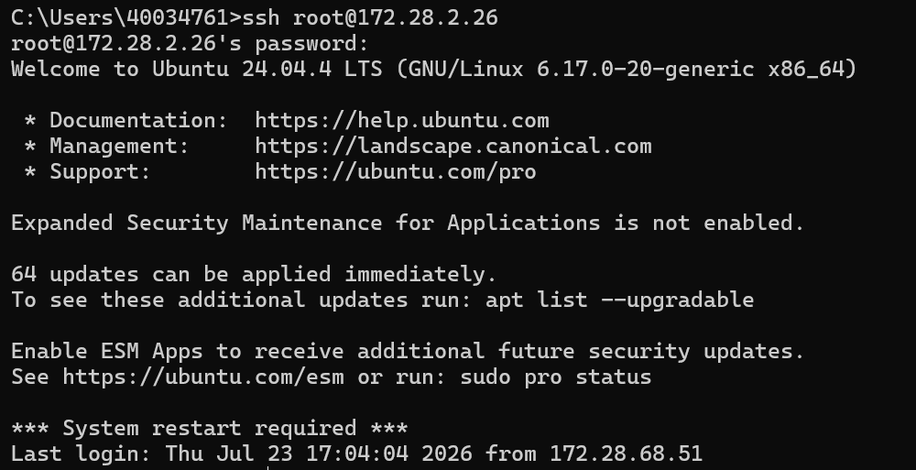  SSH to CFS VIP 172.28.2.26: authenticated successfully. The VIP transparently routes the session to whichever CFS node is currently the HA Primary.  Access via RFS Virtual IP (VIP) 172.28.2.27  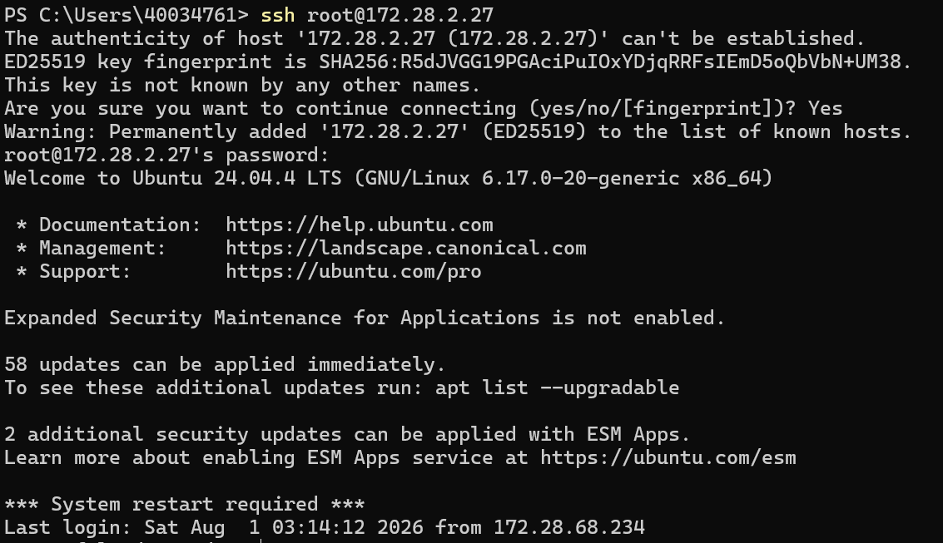  SSH to RFS VIP 172.28.2.27: host key accepted on first connect, authenticated successfully. The VIP transparently routes the session to whichever RFS node is currently the HA Primary.  Administrator logging into the NSO CLI via the CFS and RFS Virtual IPs. Individual physical nodes (172.28.2.11-13 for CFS, 172.28.2.14-16 for RFS) remain independently reachable via SSH for maintenance purposes, but standard operational access is now performed exclusively through the HA VIPs.  Per-Node Verification (individual cluster members)  CFS Node 1 - 172.28.2.11 (leader-prod, HA Primary)  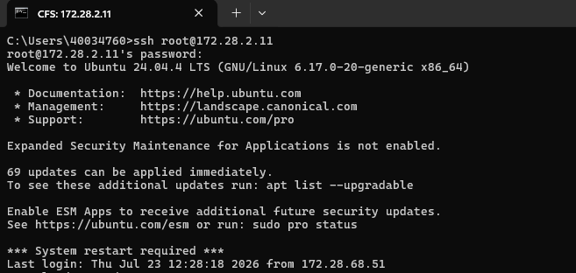  ssh root@172.28.2.11: authenticated successfully.  CFS Node 2 - 172.28.2.12 (follower1-prod, HA Secondary1)  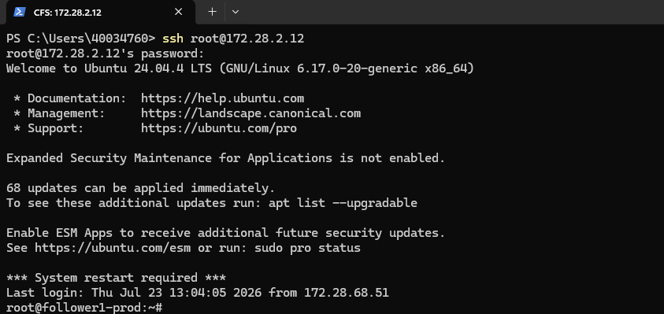  ssh root@172.28.2.12: authenticated successfully.  CFS Node 3 - 172.28.2.13 (follower2-prod, HA Secondary2)  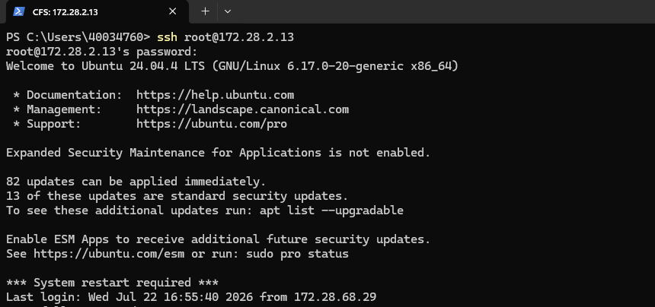  ssh root@172.28.2.13: authenticated successfully.  RFS Node 1 - 172.28.2.14 (rfsleaderprod, HA Primary)  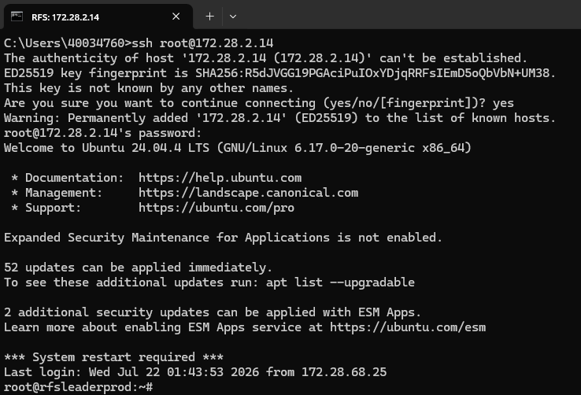  ssh root@172.28.2.14: authenticated successfully.  RFS Node 2 - 172.28.2.15 (rfsfollower1prod, HA Secondary1)  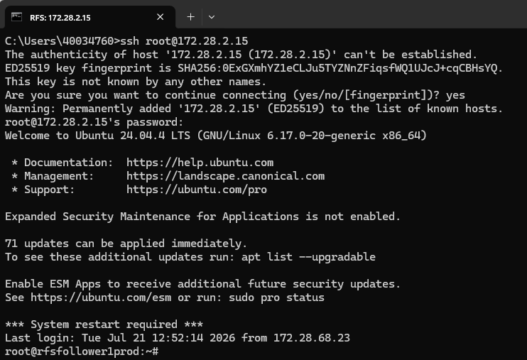  ssh root@172.28.2.15: authenticated successfully.  RFS Node 3 - 172.28.2.16 (rfsfollower2prod, HA Secondary2)  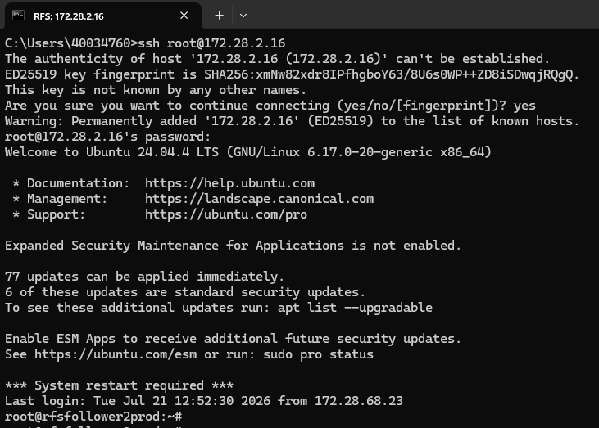  ssh root@172.28.2.16: authenticated successfully.  All six underlying physical nodes remain individually reachable via SSH on their own IPs (172.28.2.11-13 CFS, 172.28.2.14-16 RFS), confirming platform access controls at the node level in addition to VIP-level access above.
Authenticating into the NSO Environment (Login)

Test Case 2: Verifying System Health and Runtime Status
Test No. | TC-2 | Revision: | 1.0
Test Category: | Access and System Health Verification
Test Title: | Verifying System Health and Runtime Status
Description / Purpose: | Validates that the Cisco NSO orchestration engine is running correctly on the CFS and RFS clusters by confirming key runtime parameters including NSO version, daemon PID, active modules, HA cluster role (Primary/Secondary, rule-based algorithm), configuration file location, installation directory, and runtime directory are all reported without error when accessed via the CFS and RFS VIPs.
Procedure: | 1. Access the Linux shell/CLI via the CFS VIP (172.28.2.26) and RFS VIP (172.28.2.27).  2. Execute the command: ncs --status (using the full binary path /home/nso/nso-6.4/bin/ncs --status where the ncs binary is not yet on PATH).  3. Review the output for NSO version, daemon state, running modules, process ID, HA cluster status (mode: primary/secondary, node id, connected secondaries), configuration file, installation directory, and runtime directory. Also review the High Availability page in the Crosswork NSO WebUI, which shows the running/configured HA role of every node in the cluster in a single view.  4. Confirm that the NSO status is displayed as started and all required modules are running on each node.
Expected Result: | The command should successfully display the NSO runtime details on every node. The NSO status should be started, the daemon process should be running with a valid PID, the configured modules (backplane, netconf, cdb, cli, snmp, webui) should be active, and the HA cluster status should show exactly one node in primary mode per cluster with the remaining nodes connected as secondary.
Result: | ☐ OK ☐ Not OK
Passed: (initial)
Failed: (initial)
Reason for Failure:
Remarks: | Verified and logs captured
Logs/Snaps: (if Any) | HA Cluster Status - Crosswork NSO WebUI (High Availability page)  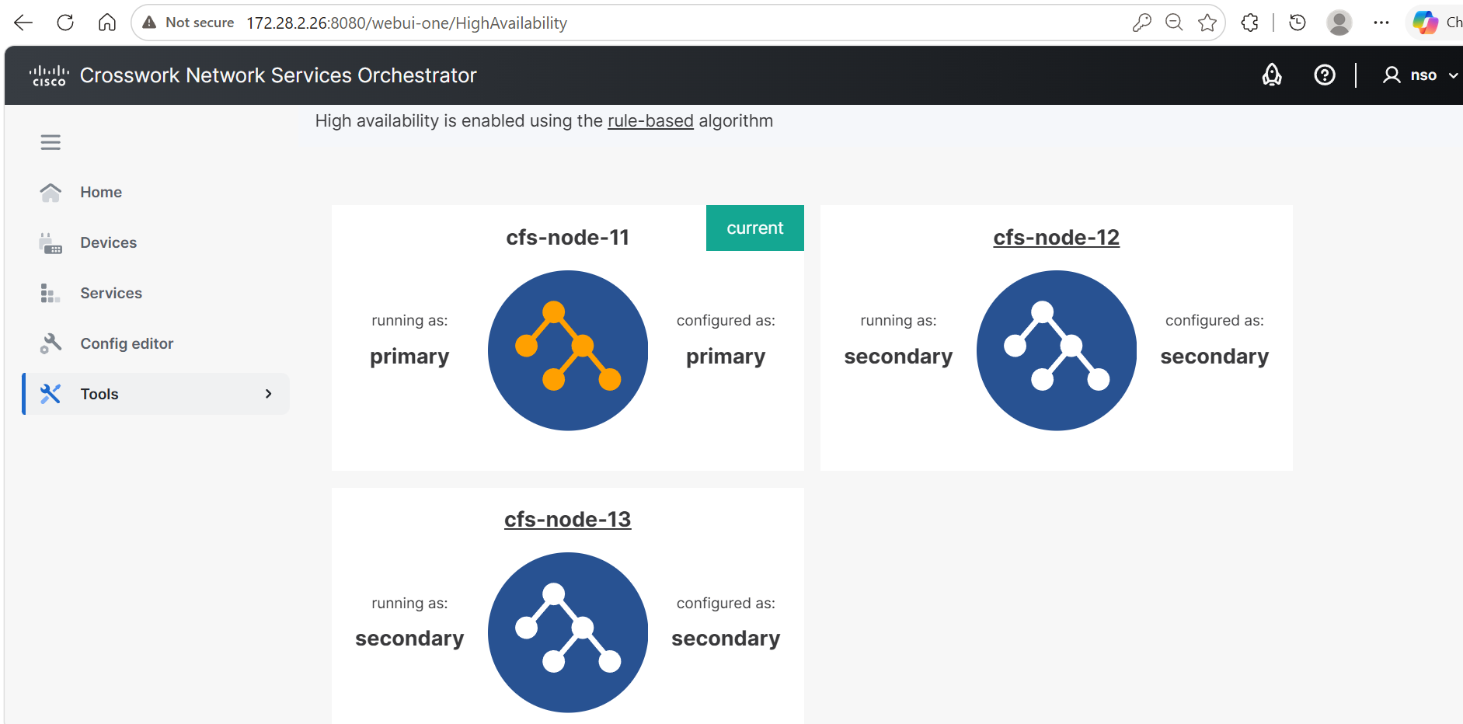  CFS HA status via WebUI (172.28.2.26:8080/webui-one/HighAvailability): High availability is enabled using the rule-based algorithm. cfs-node-11 is running as primary (configured as primary, marked "current"); cfs-node-12 and cfs-node-13 are running as secondary (configured as secondary).  ncs --status via CFS VIP 172.28.2.26  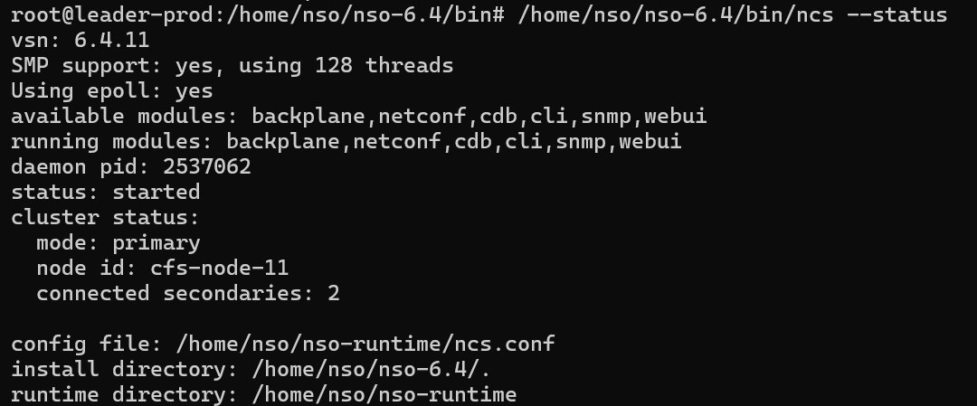  CFS VIP 172.28.2.26 - ncs --status: vsn 6.4.11, status: started, all modules (backplane, netconf, cdb, cli, snmp, webui) running, daemon pid reported. cluster status: mode: primary, node id: cfs-node-11, connected secondaries: 2.  ncs --status via RFS VIP 172.28.2.27  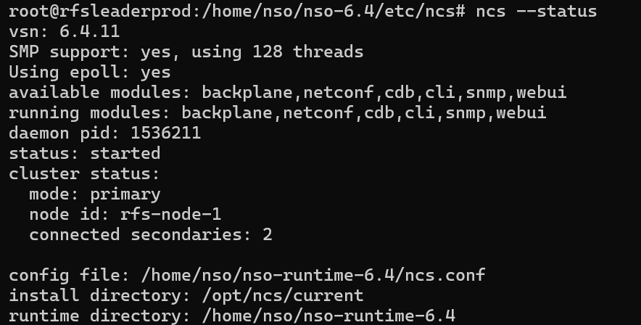  RFS VIP 172.28.2.27 - ncs --status: vsn 6.4.11, status: started, all modules running. cluster status: mode: primary, node id: rfs-node-1, connected secondaries: 2.  NSO status check confirming the platform is running and the HA cluster (rule-based algorithm) reports exactly one Primary per cluster, with the remaining nodes connected as Secondary, on both the CFS and RFS clusters.  Per-Node Verification (individual cluster members)  CFS Node 1 - 172.28.2.11 (leader-prod, HA Primary):  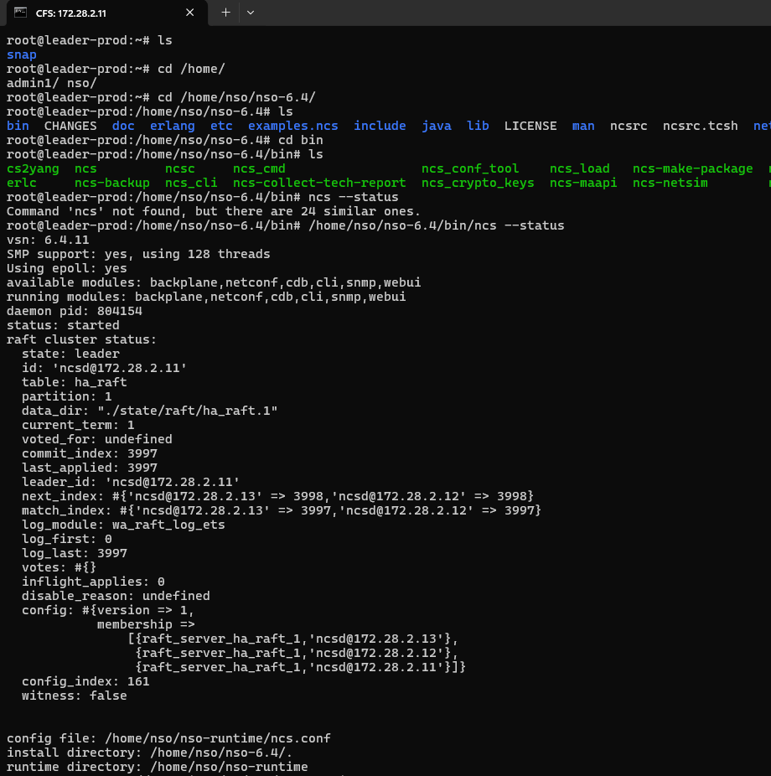  ncs --status: vsn 6.4.11, status: started, all required modules running, daemon PID reported. Node-level HA role: primary.  CFS Node 2 - 172.28.2.12 (follower1-prod, HA Secondary1):  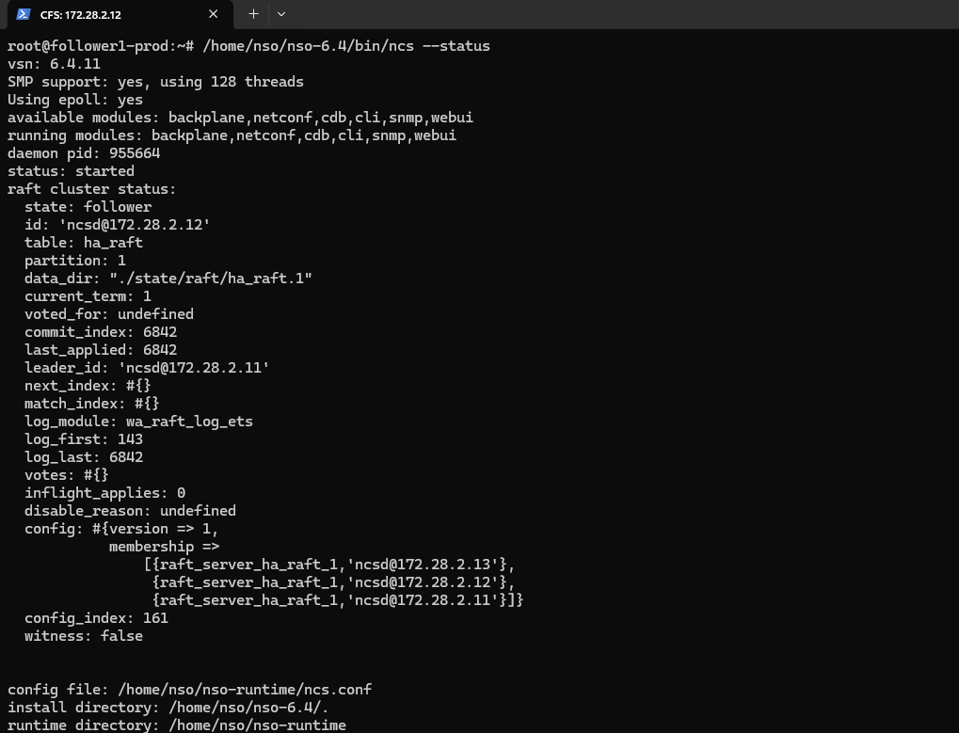  ncs --status: status: started, all required modules running. Node-level HA role: secondary, connected to primary (172.28.2.11).  CFS Node 3 - 172.28.2.13 (follower2-prod, HA Secondary2):  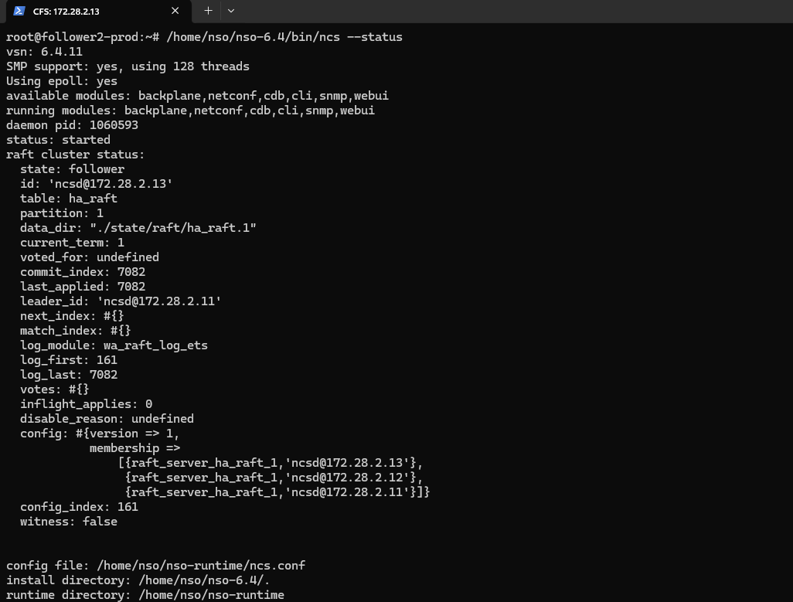  ncs --status: status: started, all required modules running. Node-level HA role: secondary, connected to primary (172.28.2.11).  RFS Node 1 - 172.28.2.14 (rfsleaderprod, HA Primary):  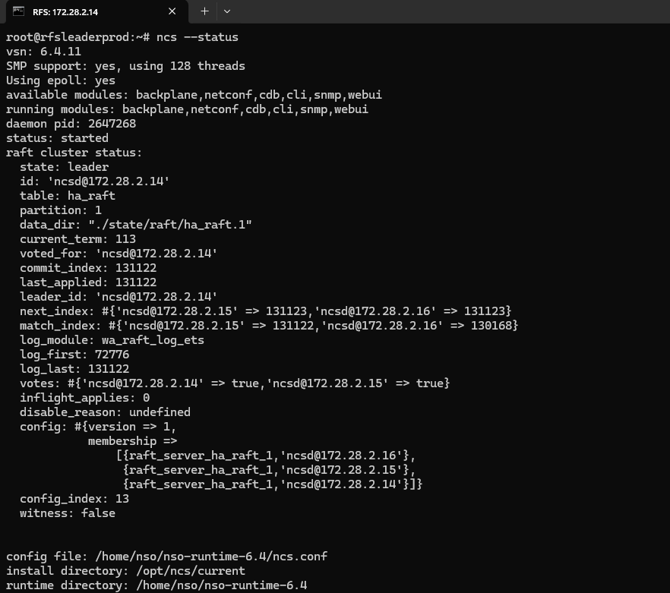  ncs --status: status: started, all required modules running. Node-level HA role: primary.  RFS Node 2 - 172.28.2.15 (rfsfollower1prod, HA Secondary1):  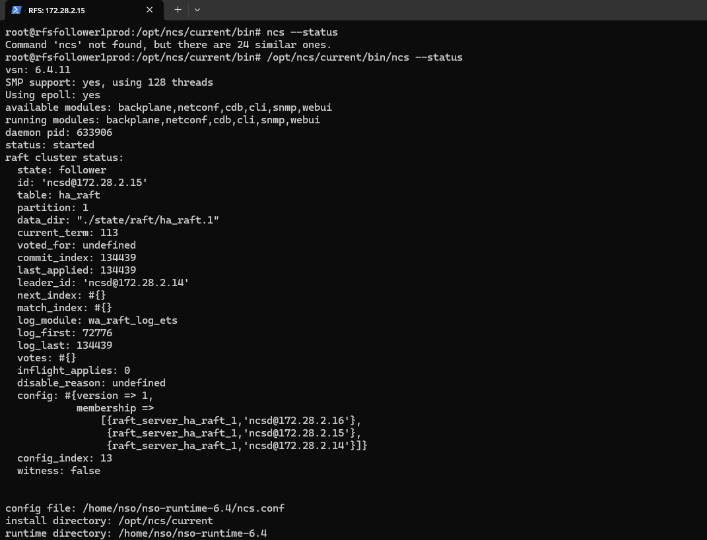  ncs --status: status: started, all required modules running. Node-level HA role: secondary, connected to primary (172.28.2.14).  RFS Node 3 - 172.28.2.16 (rfsfollower2prod, HA Secondary2):  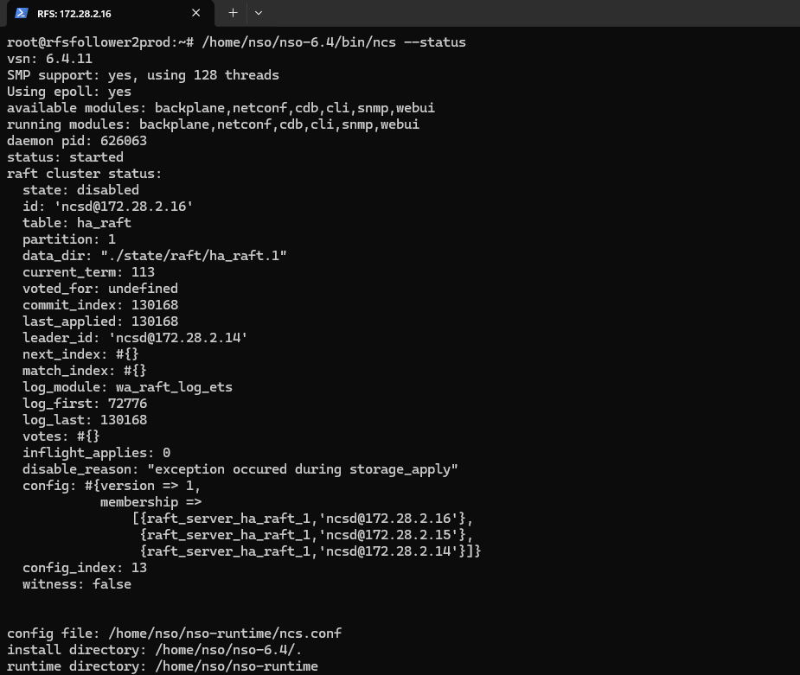  ncs --status: status: started; the NSO daemon itself remained up, though HA replication to this node briefly reported an exception during the capture window (transient - not a sustained fault). Node-level HA role: secondary.  Individual node status confirms the NSO daemon is started on every one of the six physical nodes, with HA role (primary/secondary) reported consistently with the cluster-wide VIP-level view shown above.
Verifying System Health and Runtime Status

5. Device Connectivity and Configuration Synchronization

Test Case 3: Validating Device Reachability and Sync from the CFS
Test No. | TC-3 | Revision: | 1.0
Test Category: | Device Connectivity and Configuration Synchronization
Test Title: | Validating Device Reachability and Sync from the CFS
Description / Purpose: | Verifying end-to-end device handling in Cisco NSO from the CFS cluster: confirming the RFS cluster is registered as a single device (RFS-27) addressed at the RFS VIP, verifying connectivity from the CFS VIP, and confirming that configuration sync (devices sync-from) succeeds via the CFS VIP, which always routes to the current HA Primary.
Procedure: | 1. Run show devices list via the CFS VIP (172.28.2.26) to confirm the device RFS-27 (172.28.2.27, the RFS VIP) is registered and unlocked. Also confirm the same device is visible in the Devices page of the Crosswork NSO WebUI at 172.28.2.26:8080.  2. Execute devices device RFS-27 connect via the CFS VIP to validate reachability and establish a session with the RFS VIP.  3. Perform devices sync-from via the CFS VIP to pull the live configuration from RFS-27 into NSO, and confirm the sync completes successfully. Because the VIP always routes to the current HA Primary, the sync is expected to succeed consistently, without needing to test individual physical node roles.
Expected Result: | The device RFS-27 appears in the list with the correct address (172.28.2.27) and NED ID, on both the CLI and the WebUI, when accessed via the CFS VIP. The connection attempt via the CFS VIP returns result true with confirmation of successful connectivity to RFS-27 (172.28.2.27:2022). Because the CFS VIP always routes to the current HA Primary, and only the Primary may write to the CDB, devices sync-from via the CFS VIP is expected to return result true. Direct write access to a Secondary node (bypassing the VIP) is still correctly rejected with info "node is in read-only mode" - this is normal CFS HA behavior, not a fault.
Result: | ☐ OK ☐ Not OK
Passed: (initial)
Failed: (initial)
Reason for Failure:
Remarks: | Verified and logs captured
Logs/Snaps: (if Any) | Devices page - Crosswork NSO WebUI (CFS VIP)  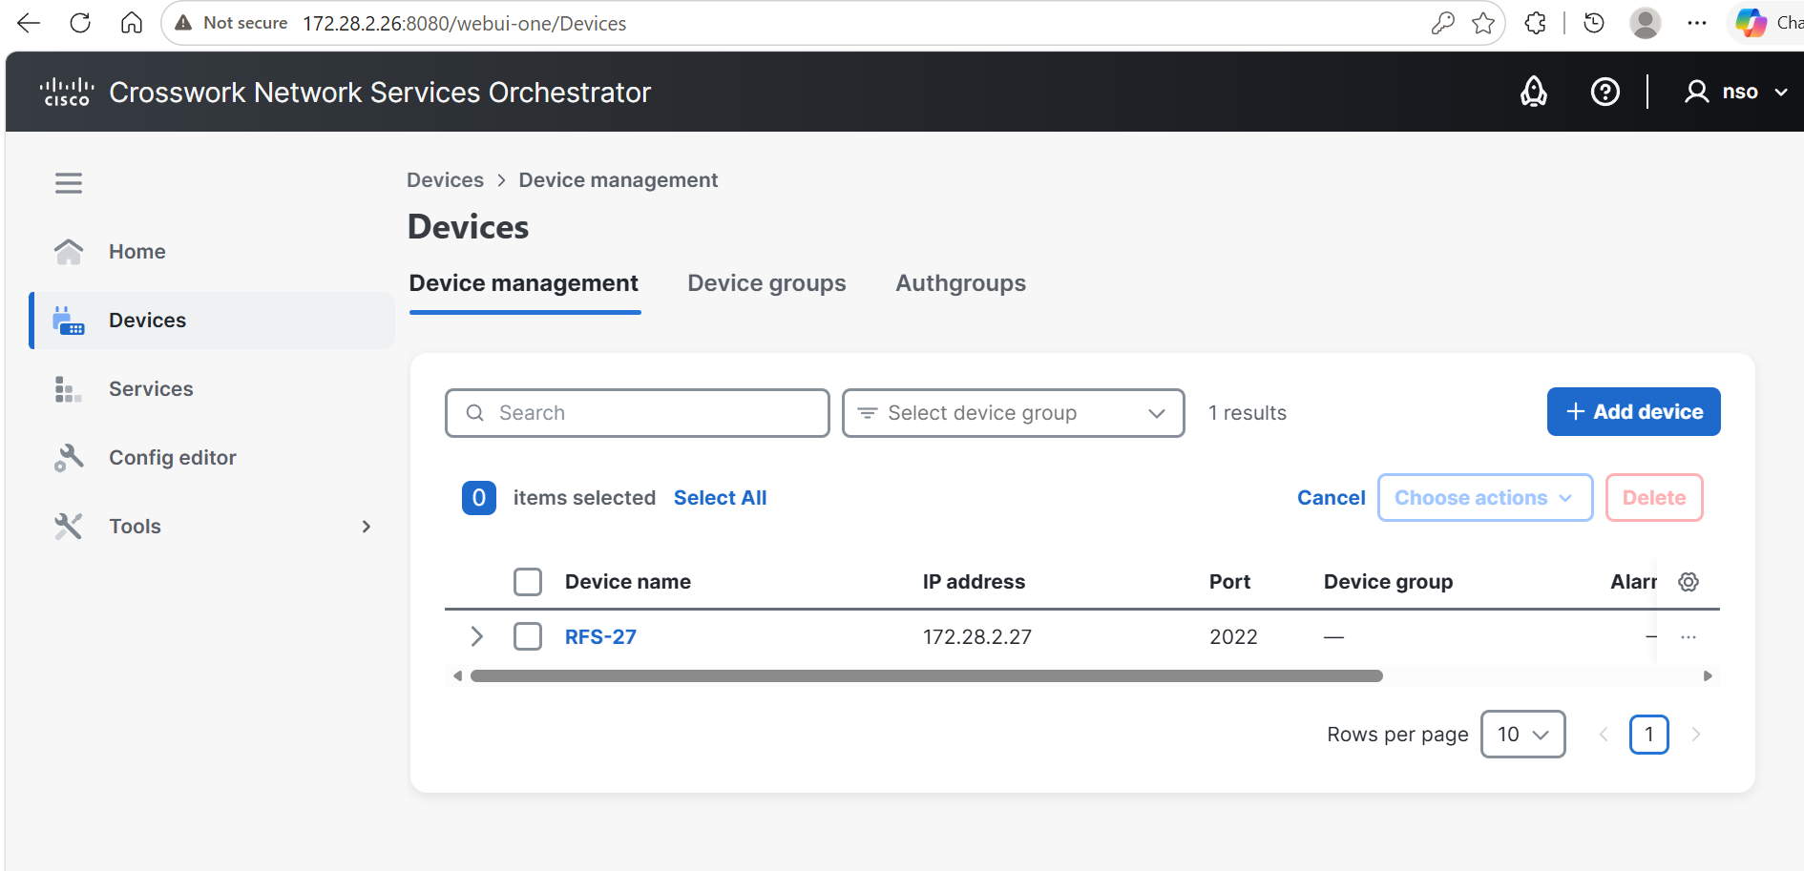  CFS VIP 172.28.2.26:8080/webui-one/Devices: Device management shows a single registered device, RFS-27, at address 172.28.2.27 (the RFS VIP), port 2022.  show devices list (CFS VIP)  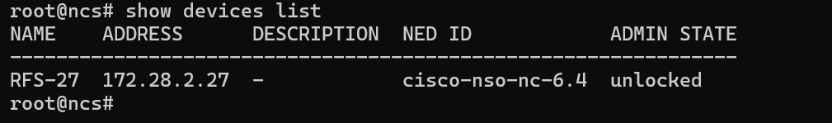  CFS VIP 172.28.2.26 - show devices list: device RFS-27, address 172.28.2.27, NED ID cisco-nso-nc-6.4, admin state unlocked.  devices device RFS-27 connect (CFS VIP)  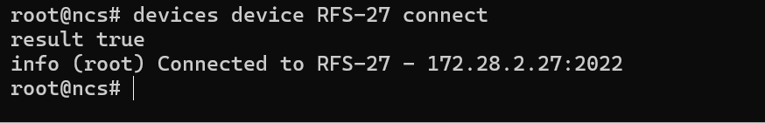  CFS VIP 172.28.2.26 - devices device RFS-27 connect: result true, info "Connected to RFS-27 - 172.28.2.27:2022".  devices sync-from (CFS VIP)  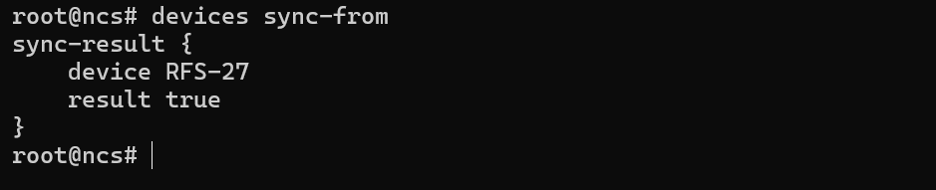  CFS VIP 172.28.2.26 - devices sync-from: sync-result { device RFS-27, result true }.  Device connectivity and configuration sync confirmed end-to-end from the CFS VIP to the RFS VIP. Because the VIP always routes to the current HA Primary, sync-from succeeds consistently without needing to test individual node roles; failover to a Secondary is handled transparently by the HA layer.  Per-Node Verification (individual cluster members, prior device model)  CFS Node 1 - 172.28.2.11 (leader-prod, HA Primary):  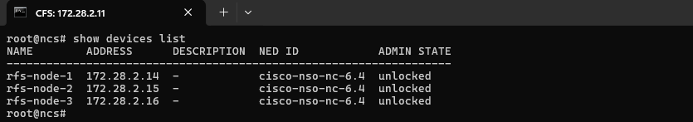  show devices list: rfs-node-1 (172.28.2.14), rfs-node-2 (172.28.2.15), rfs-node-3 (172.28.2.16), NED cisco-nso-nc-6.4, all unlocked.  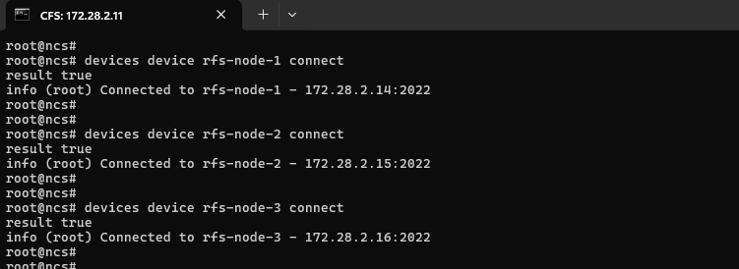  devices device connect for rfs-node-1/2/3: result true for all three, e.g. "Connected to rfs-node-1 - 172.28.2.14:2022".  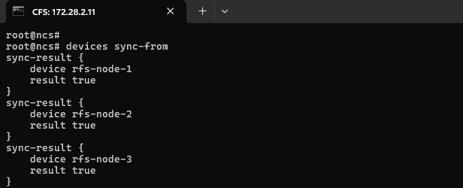  devices sync-from: sync-result true for rfs-node-1, rfs-node-2, and rfs-node-3.  CFS Node 2 - 172.28.2.12 (follower1-prod, HA Secondary1):  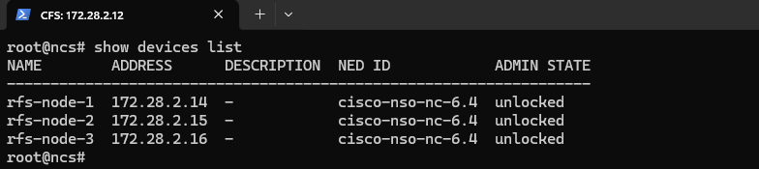  show devices list: same three rfs-node devices, all unlocked.  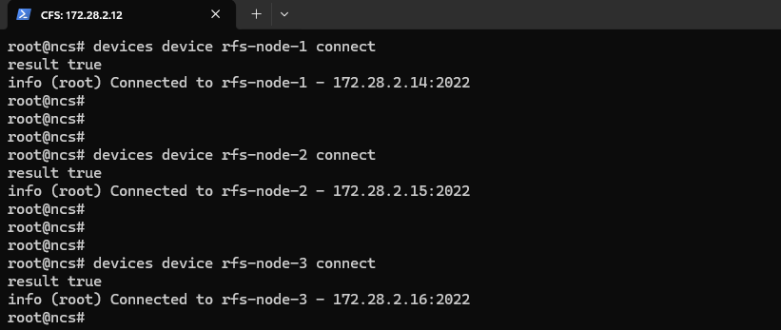  devices device connect for rfs-node-1/2/3: result true for all three.  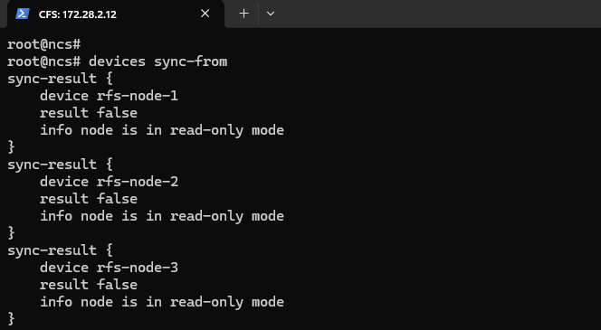  devices sync-from: result false for all three devices, info "node is in read-only mode" (expected - only the HA Primary may write).  CFS Node 3 - 172.28.2.13 (follower2-prod, HA Secondary2):  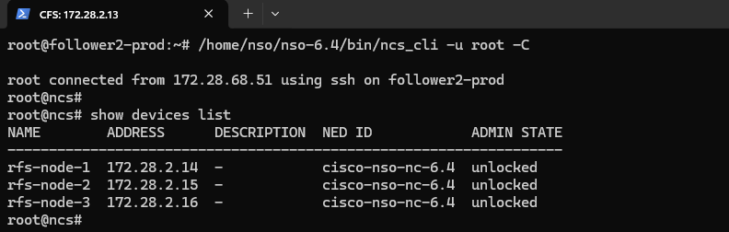  show devices list: same three rfs-node devices, all unlocked.  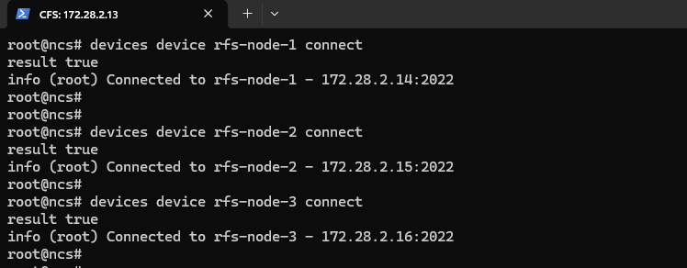  devices device connect for rfs-node-1/2/3: result true for all three.  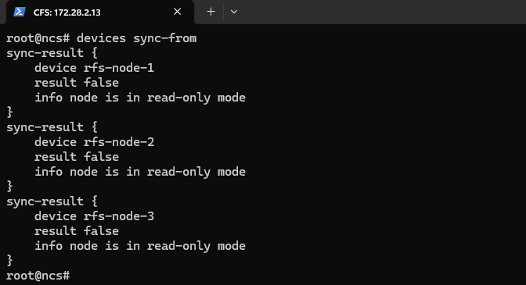  devices sync-from: result false for all three devices, info "node is in read-only mode" (expected, same reason as Secondary1).  This per-node evidence was captured under the prior device model, in which the CFS registered each RFS node individually (rfs-node-1/2/3). It is retained to show node-level read/write behavior under HA. Current provisioning uses the single RFS-27 device via the RFS VIP shown above, which is reachable and writable through any CFS node because the VIP always resolves to whichever node is the current HA Primary.
Table 4: Validating Device Reachability and Sync from the CFS

Test Case 4: Validating Device Reachability and Sync from the RFS
Test No. | TC-4 | Revision: | 1.0
Test Category: | Device Connectivity and Configuration Synchronization
Test Title: | Validating Device Reachability and Sync from the RFS
Description / Purpose: | Validating device connectivity and configuration synchronization in Cisco NSO from the RFS cluster against the real field network devices (GPON/access nodes). This confirms that registered field devices can be reached, connected, and their live configurations synchronized into NSO's internal database, and that sync writes are correctly restricted to the RFS HA Primary (accessed via the RFS VIP 172.28.2.27).
Procedure: | 1. Run show devices list to confirm the registered field devices (e.g., ADBICDAXMAR001, ADGDGOVIGPRO01, AKPTAKKAGPRO01, ALDRALLAGPRO01, ADVPADAVGPRO01, CGNTPOLAGPRO01 and other GPON/access devices - 190+ devices in total) are registered and unlocked.  2. From the RFS HA Primary (172.28.2.14), reached via the RFS VIP (172.28.2.27), execute devices device <name> connect for a representative device to validate reachability and establish a session. Example: devices device CGNTPOLAGPRO01 connect  3. From the RFS HA Primary (via the RFS VIP), perform devices device <name> sync-from (and a bulk devices sync-from) to pull the live configuration into NSO. Example: devices device CGNTPOLAGPRO01 sync-from  4. Repeat show devices list and devices sync-from directly against each RFS Secondary node (172.28.2.15, 172.28.2.16, bypassing the VIP) to confirm read-only behavior is correctly enforced.
Expected Result: | Devices appear in the list with correct addresses, NED IDs, and admin states set to unlocked. From the RFS HA Primary (via the RFS VIP), the connection attempt returns result true with confirmation of successful connectivity (e.g., "Connected to CGNTPOLAGPRO01 - 172.16.1.123:22"), and sync-from returns result true. From RFS Secondary nodes (direct access, bypassing the VIP), sync-from is expected to return result false with info "node is in read-only mode" for each device - normal RFS HA behavior, since only the Primary may write to the CDB.
Result: | ☐ OK ☐ Not OK
Passed: (initial)
Failed: (initial)
Reason for Failure:
Remarks: | Verified and logs captured
Logs/Snaps: (if Any) | 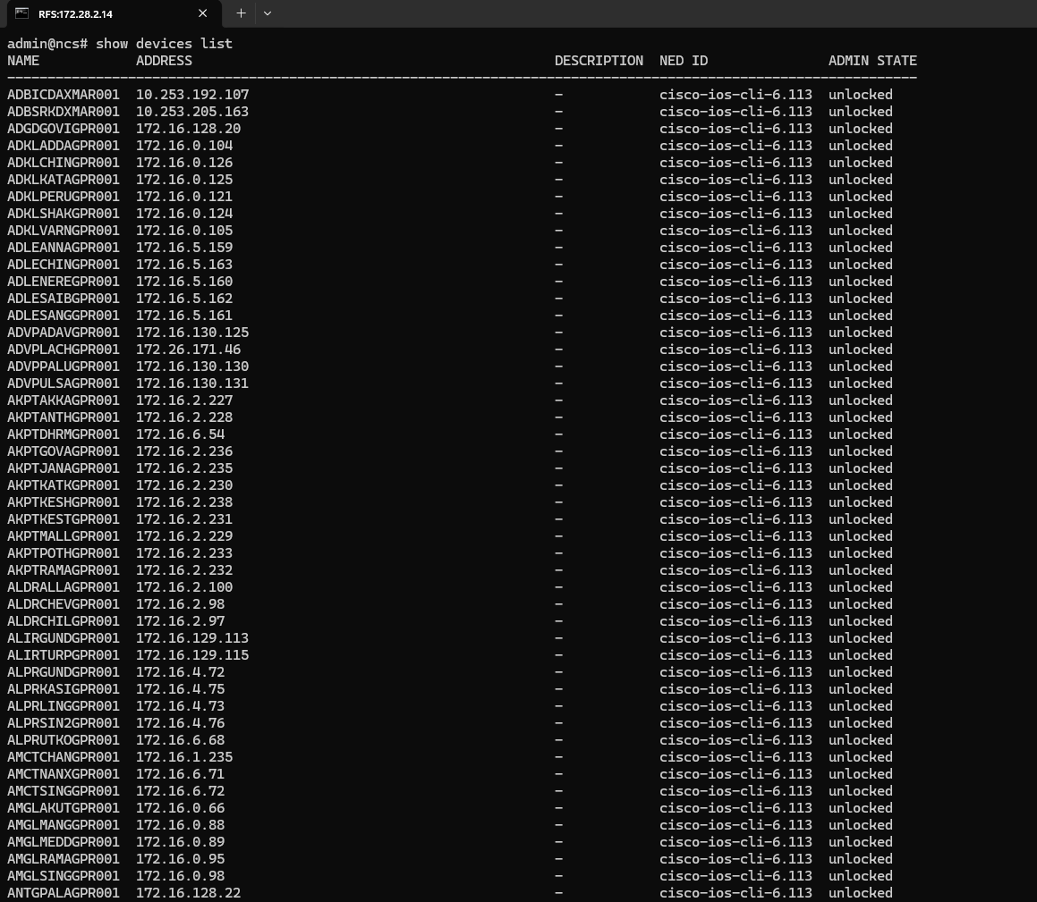  show devices list from RFS VIP (field devices)  RFS 172.28.2.14 (Primary, via RFS VIP 172.28.2.27) - show devices list: 190+ field devices registered (e.g., ADBICDAXMAR001 - 10.253.192.107, ADGDGOVIGPRO01 - 172.16.128.20, AKPTAKKAGPRO01 - 172.16.2.227), NED cisco-ios-cli-6.113, all unlocked.  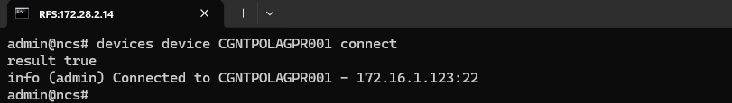  RFS 172.28.2.14 (Primary, via RFS VIP) - devices device CGNTPOLAGPRO01 connect: result true, "Connected to CGNTPOLAGPRO01 - 172.16.1.123:22".  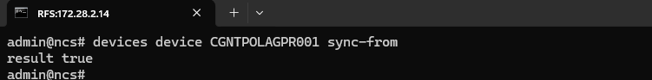  RFS 172.28.2.14 (Primary, via RFS VIP) - devices device CGNTPOLAGPRO01 sync-from: result true.  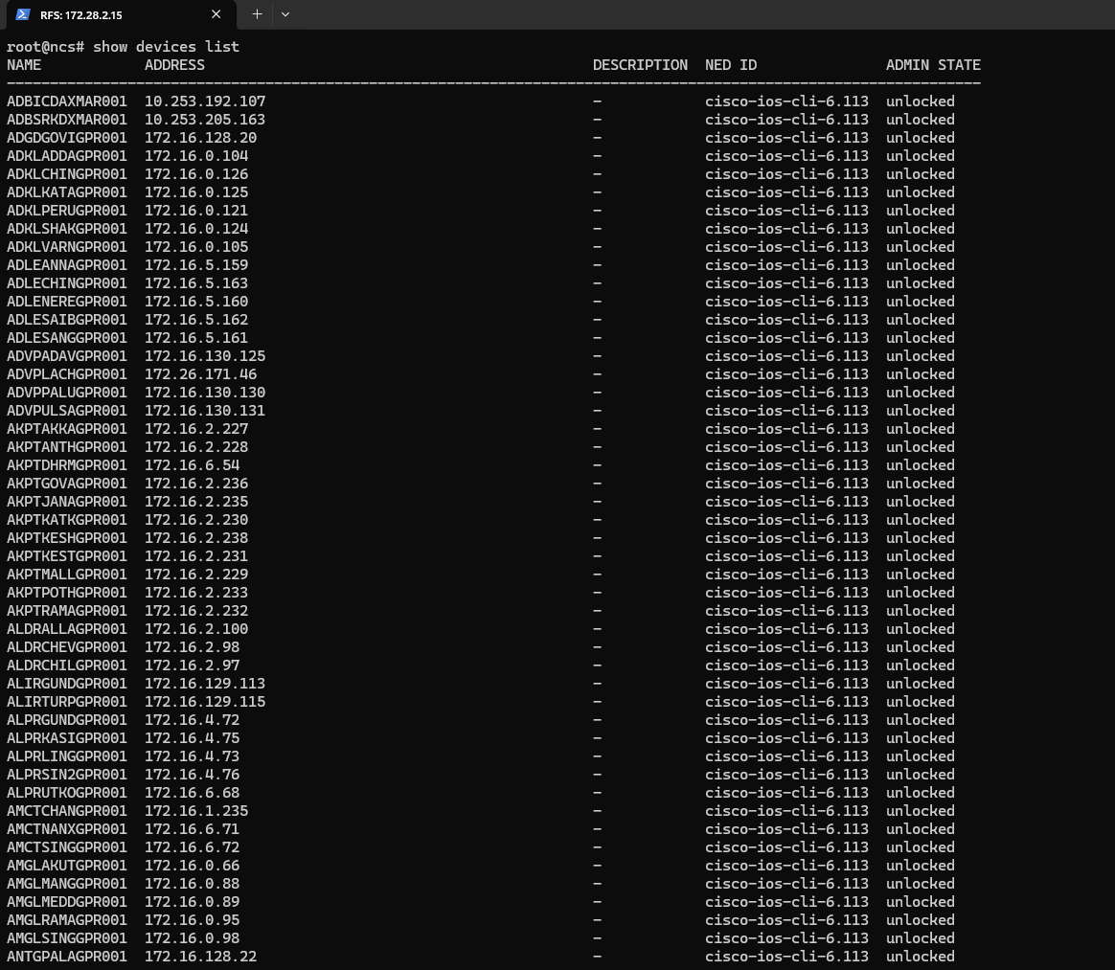  RFS 172.28.2.15 (Secondary1) - show devices list: same full 190+ device inventory, all unlocked.  RFS 172.28.2.15 (Secondary1) - devices sync-from (bulk, all devices): result false for each device, info "node is in read-only mode".  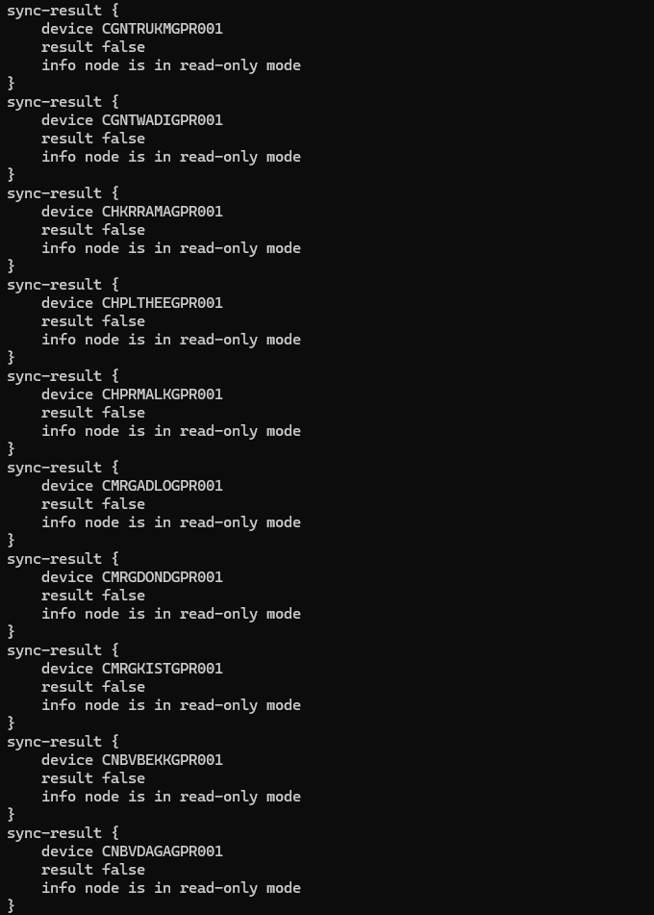  RFS 172.28.2.15 (Secondary1) - devices sync-from continued: result false / "node is in read-only mode" for devices including CGNTRUKMGPR01, CGNTWADIGPR01, CHKRRAMAGPR01, CHPLTHEEGPR01, CHPRMALKGPR01, CMRGADLOGPR01, CMRGDONDGPR01, CMRGKISTGPR01, CNBVBEKKGPR01, CNBVDAGAGPR01 (expected - only the RFS HA Primary may write).  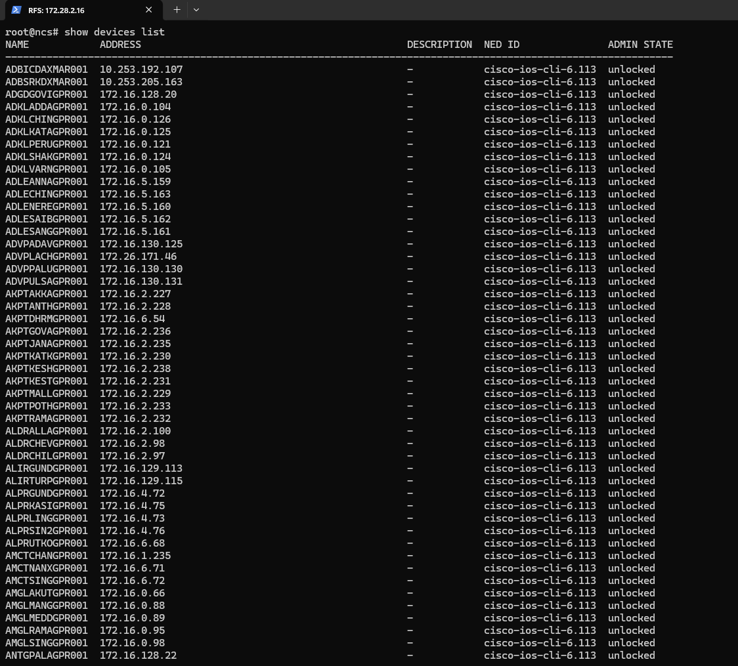  RFS 172.28.2.16 (Secondary2) - show devices list: same full 190+ device inventory, all unlocked.  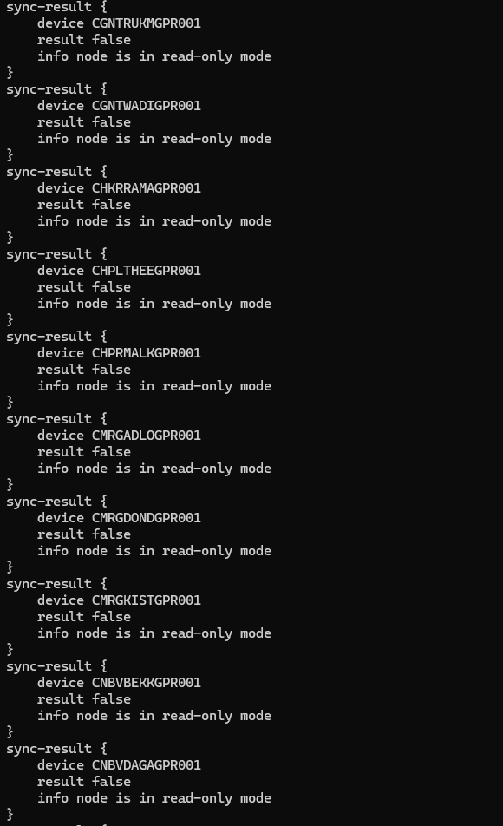  RFS 172.28.2.16 (Secondary2) - devices sync-from (bulk, all devices): command issued; result: result false / "node is in read-only mode" for each device (same sample as Secondary1), expected for a non-primary (Secondary) node.  Device connectivity list confirming reachable network devices.
Validating Device Reachability and Sync from the RFS

s

6. Package Management

Test Case 5: Verifying Installed Package Status (Service Package Check)
Test No. | TC-5 | Revision: | 1.0
Test Category: | Package Management
Test Title: | Verifying Installed Package Status (Service Package Check)
Description / Purpose: | Verify that the installed NSO packages are displayed along with their operational status.
Procedure: | 1. Execute the command: show packages package oper-status.  2. Review the list of installed packages displayed in the output.  3. Verify the package names and their operational status.  4. Confirm that the package operational status information is displayed for all listed packages.
Expected Result: | The command should display the list of installed packages along with an operational status of "up" for every package, on every CFS and RFS node.
Result: | ☐ OK ☐ Not OK
Passed: (initial)
Failed: (initial)
Reason for Failure:
Remarks: | Verified and logs captured
Logs/Snaps: (if Any) | 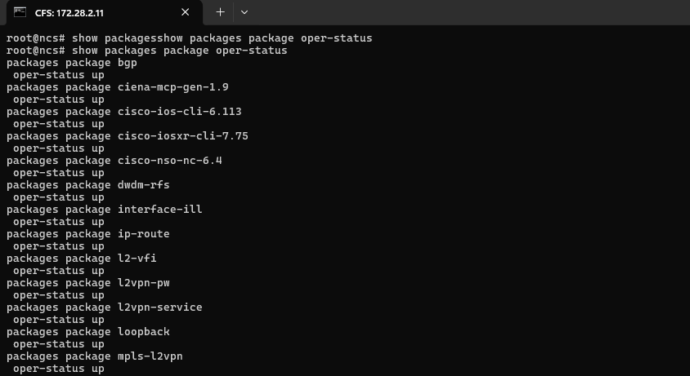CFS 172.28.2.11 (Primary, via CFS VIP 172.28.2.26) - show packages package oper-status (part 1 of 2): bgp, ciena-mcp-gen-1.9, cisco-ios-cli-6.113, cisco-iosxr-cli-7.75, cisco-nso-nc-6.4, dudm-rfs, interface-ill, ip-route, l2-vfi, l2vpn-pw, l2vpn-service, loopback, mpls-l2vpn - all oper-status up.  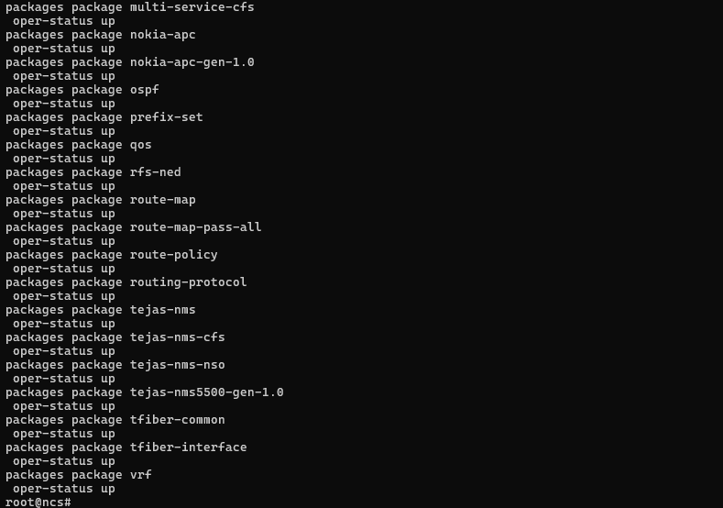  CFS 172.28.2.11 (Primary, via CFS VIP 172.28.2.26) - show packages package oper-status (part 2 of 2): multi-service-cfs, nokia-apc, nokia-apc-gen-1.0, ospf, prefix-set, qos, rfs-ned, route-map, route-map-pass-all, route-policy, routing-protocol, tejas-nms, tejas-nms-cfs, tejas-nms-nso, tejas-nms5500-gen-1.0, tfiber-common, tfiber-interface, vrf - all oper-status up.  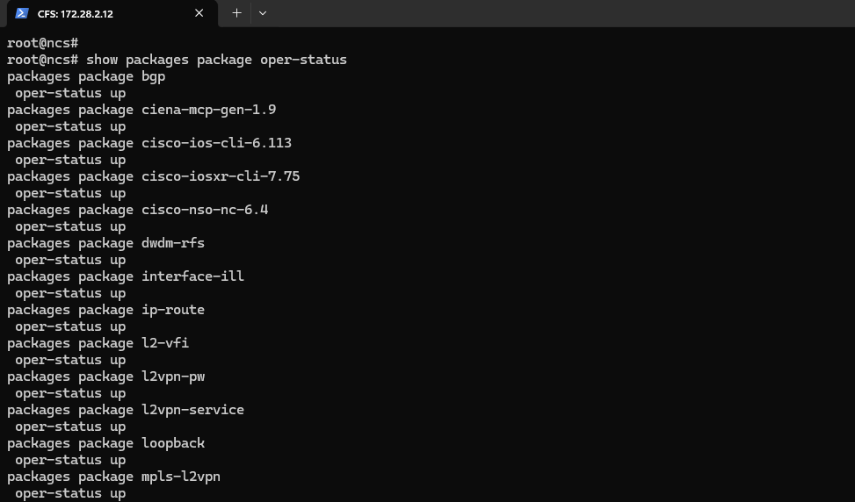  CFS 172.28.2.12 (Secondary1) - show packages package oper-status (part 1 of 2): same CFS package set, all oper-status up.  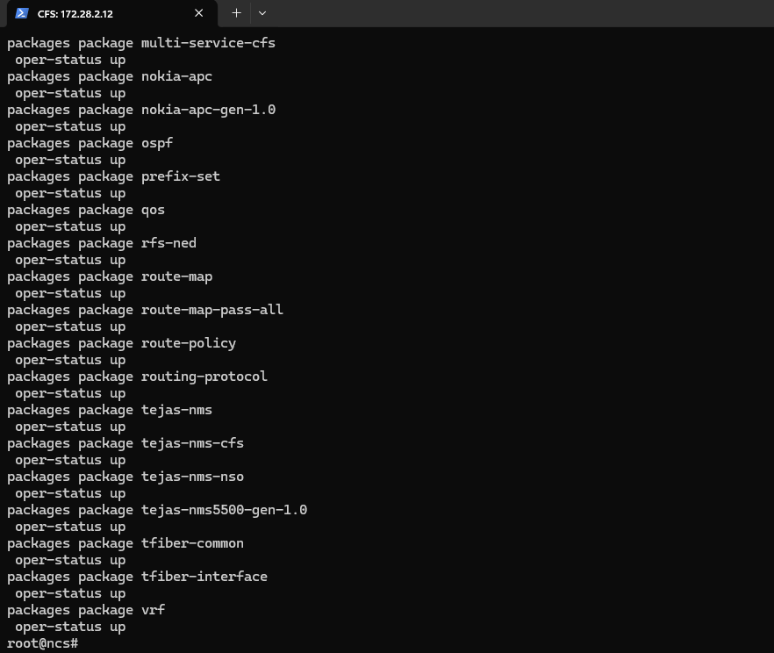  CFS 172.28.2.12 (Secondary1) - show packages package oper-status (part 2 of 2): same CFS package set, all oper-status up.    CFS 172.28.2.13 (Secondary2) - show packages package oper-status (part 1 of 2): same CFS package set, all oper-status up.  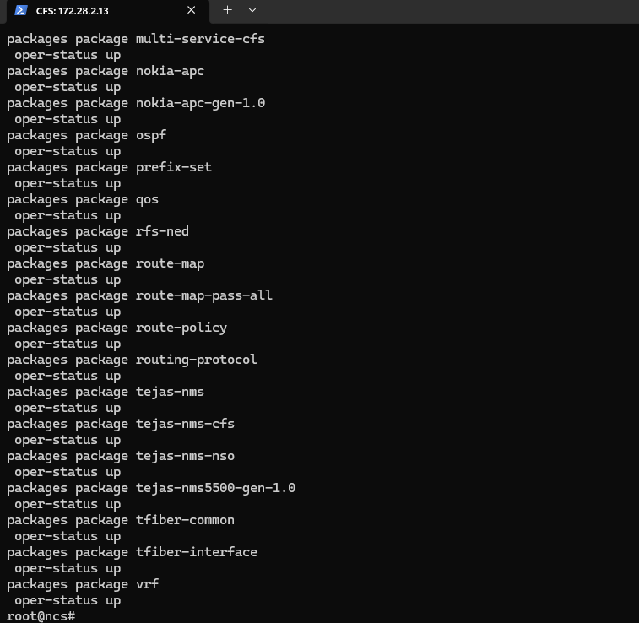  CFS 172.28.2.13 (Secondary2) - show packages package oper-status (part 2 of 2): same CFS package set, all oper-status up.  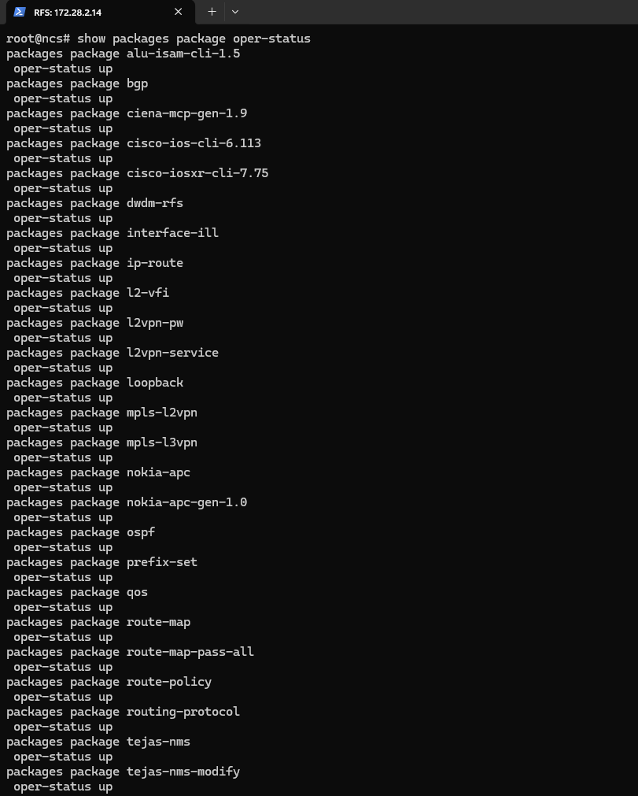  RFS 172.28.2.14 (Primary, via RFS VIP 172.28.2.27) - show packages package oper-status (part 1 of 2): alu-isam-cli-1.5, bgp, ciena-mcp-gen-1.9, cisco-ios-cli-6.113, cisco-iosxr-cli-7.75, dudm-rfs, interface-ill, ip-route, l2-vfi, l2vpn-pw, l2vpn-service, loopback, mpls-l2vpn, mpls-l3vpn, nokia-apc, nokia-apc-gen-1.0, ospf, prefix-set, qos, route-map - all oper-status up.  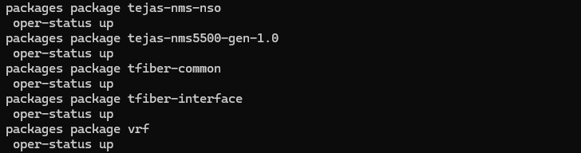RFS 172.28.2.14 (Primary, via RFS VIP 172.28.2.27) - show packages package oper-status (part 2 of 2): route-map-pass-all, route-policy, routing-protocol, tejas-nms, tejas-nms-modify, tejas-nms-nso, tejas-nms5500-gen-1.0, tfiber-common, tfiber-interface, vrf - all oper-status up.  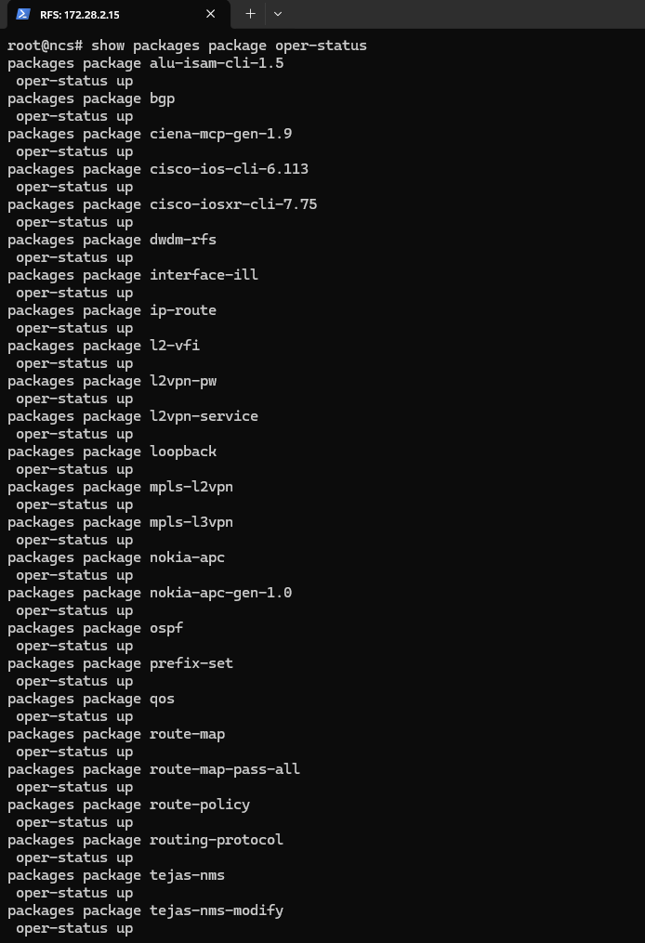  RFS 172.28.2.15 (Secondary1) - show packages package oper-status: full RFS package set, all oper-status up.  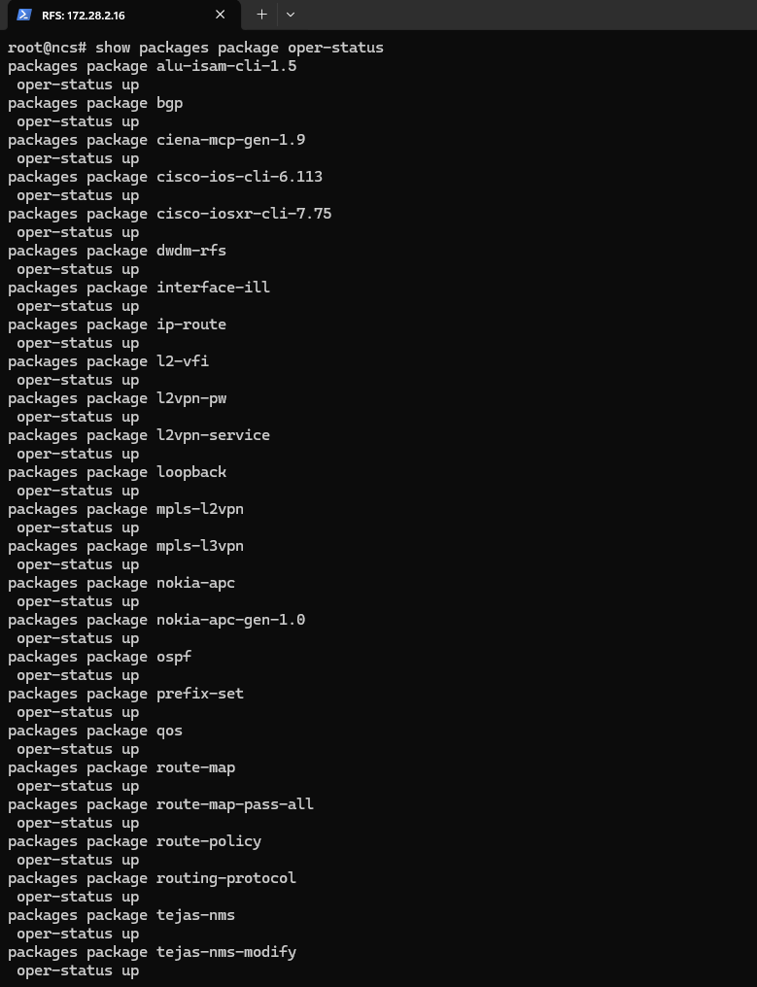RFS 172.28.2.16 (Secondary2) - show packages package oper-status: full RFS package set, all oper-status up.  Service package operational status - confirmed active.
Verifying Installed Package Status (Service Package Check)

Test Case 6: Package Upgrade Workflow
Test No. | TC-6 | Revision: | 1.0
Test Category: | Package Management
Test Title: | Package Upgrade Workflow
Description / Purpose: | Verify that the NSO package directory structure is present and consistent across all CFS and RFS cluster nodes (Primary and Secondary, behind the CFS VIP 172.28.2.26 and RFS VIP 172.28.2.27 respectively) following the migration to Cisco NSO 6.4.11.
Procedure: | 1. On each CFS node (172.28.2.11 leader-prod / Primary, 172.28.2.12 follower1-prod / Secondary1, 172.28.2.13 follower2-prod / Secondary2), navigate to the NSO packages directory: cd /home/nso/nso-6.4/packages  2. Verify that all required package directories are present: ls -ltr  3. On each RFS node (172.28.2.14 rfsleaderprod / Primary, 172.28.2.15 rfsfollower1prod / Secondary1, 172.28.2.16 rfsfollower2prod / Secondary2), navigate to the NSO home/runtime directory (or filesystem root) and run: ls -ltr  4. Note: the evidence captured for this test case consists only of the directory-listing checks above. No screenshot evidence was found for a package compile (make clean all) or packages reload step, so those steps are not represented as verified here.
Expected Result: | The package directories (tools, lsa, auth) are present and identical on all three CFS nodes. The corresponding runtime files/folders are present on all three RFS nodes. No missing or unexpected directory entries are observed on any node.
Result: | ☐ OK ☐ Not OK
Passed: (initial)
Failed: (initial)
Reason for Failure:
Remarks: | Verified and logs captured
Logs/Snaps: (if Any) | Package directory listing (ls -ltr)  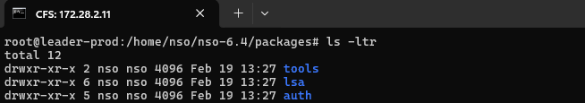  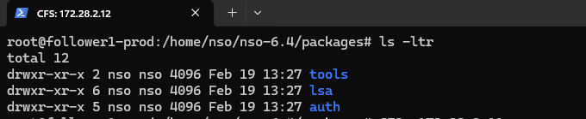  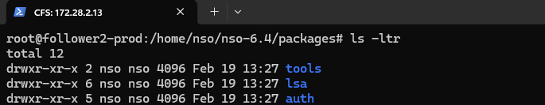  CFS 172.28.2.11 (leader-prod / Primary) - ls -ltr in /home/nso/nso-6.4/packages: directories tools, lsa, auth present (dated Feb 19, 13:27).  CFS 172.28.2.12 (follower1-prod / Secondary1) - ls -ltr in /home/nso/nso-6.4/packages: identical tools, lsa, auth directories present.  CFS 172.28.2.13 (follower2-prod / Secondary2) - ls -ltr in /home/nso/nso-6.4/packages: identical tools, lsa, auth directories present.  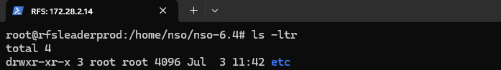  RFS 172.28.2.14 (rfsleaderprod / Primary) - ls -ltr in /home/nso/nso-6.4: etc directory present.  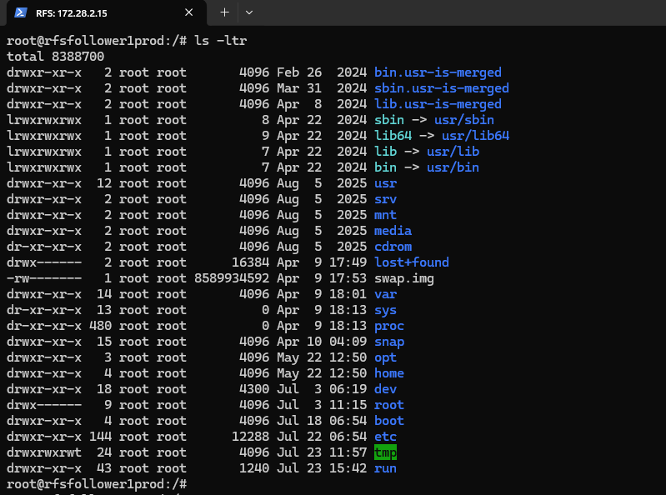  RFS 172.28.2.15 (rfsfollower1prod / Secondary1) - ls -ltr in /: standard root filesystem listing (bin, boot, dev, etc, home, lib, opt, proc, root, run, snap, srv, sys, usr, var), confirming filesystem intact.  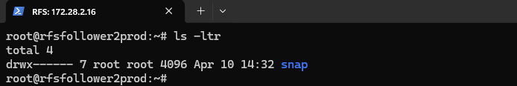  RFS 172.28.2.16 (rfsfollower2prod / Secondary2) - ls -ltr in home directory: snap directory only (dated Apr 10, 14:32).
Package Upgrade Workflow

